1.Create a new project with the help of spring initializer

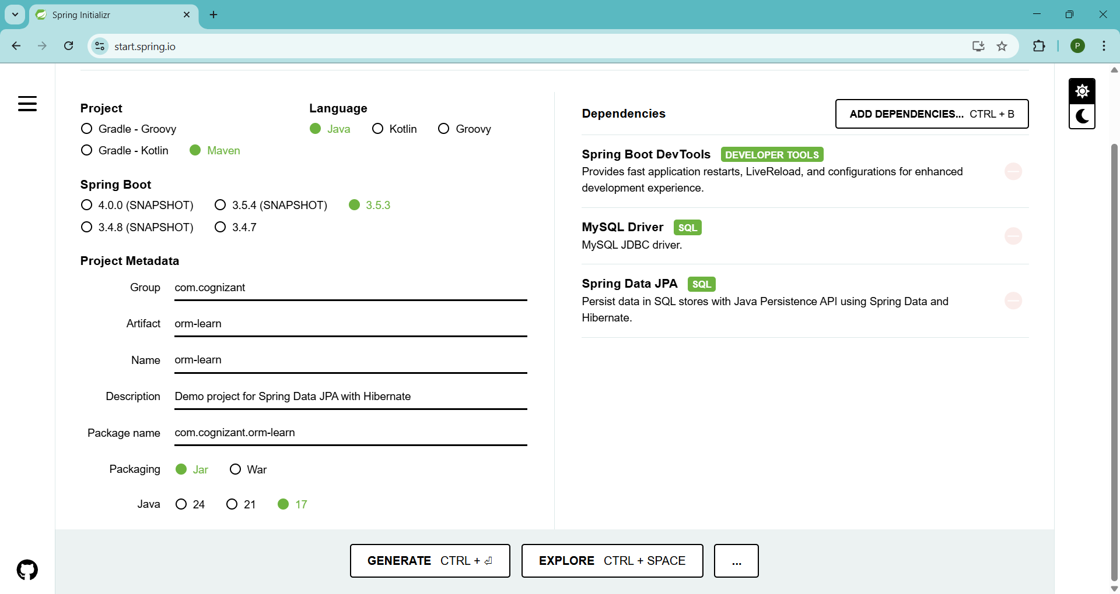

2.import the spring initializer project to eclipse

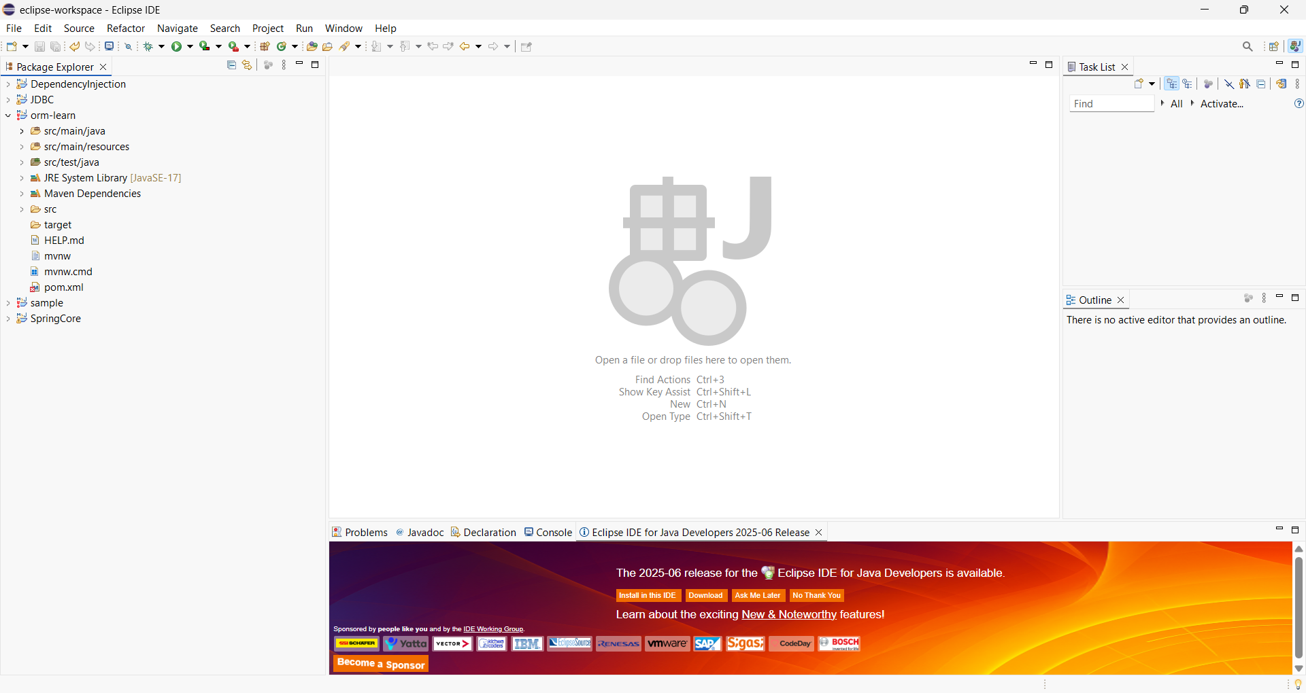

3.creating a database named ormlearn and inserting values into country table

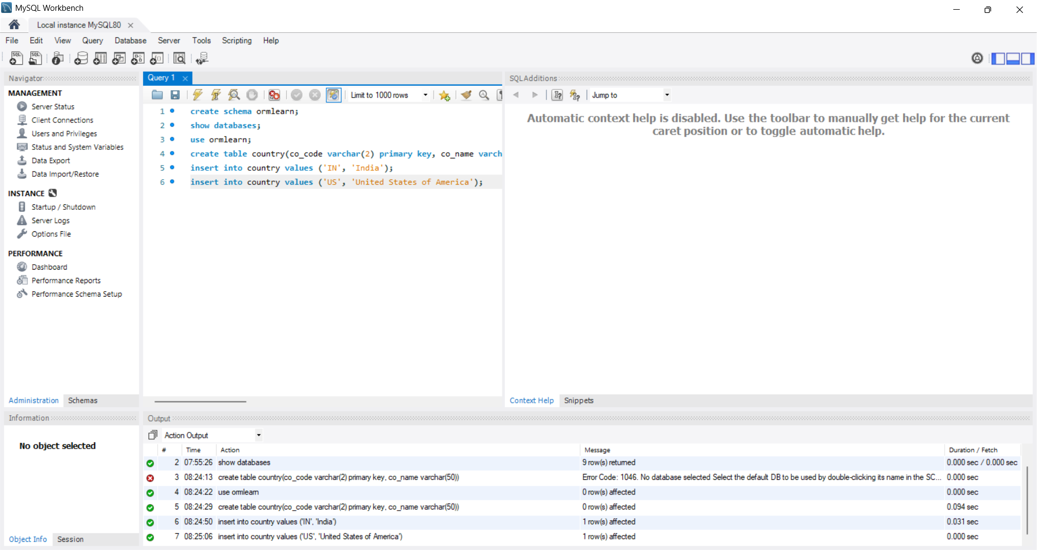

4. com.cognizant.orm_learn.model package

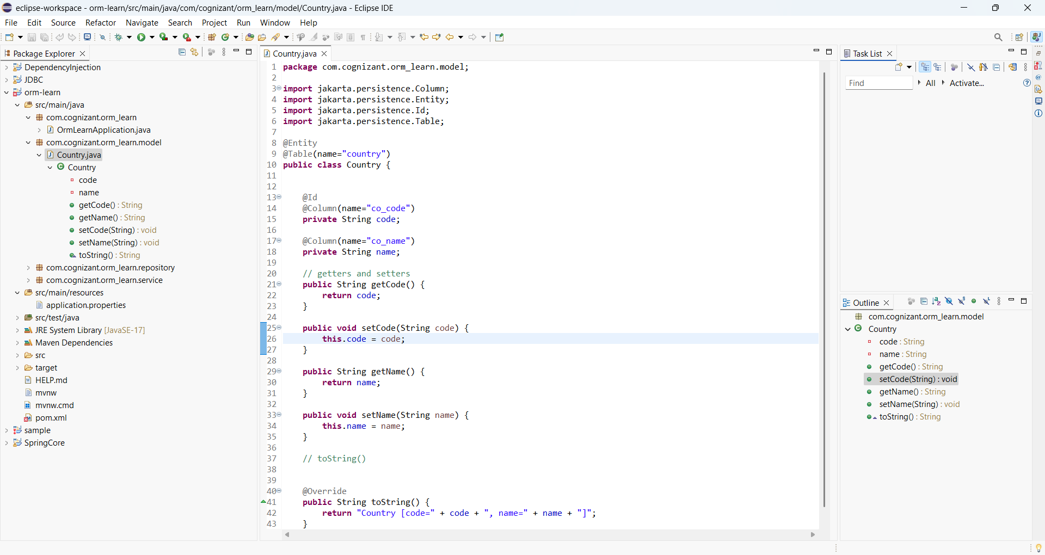

5. com.cognizant.orm_learn.repository package

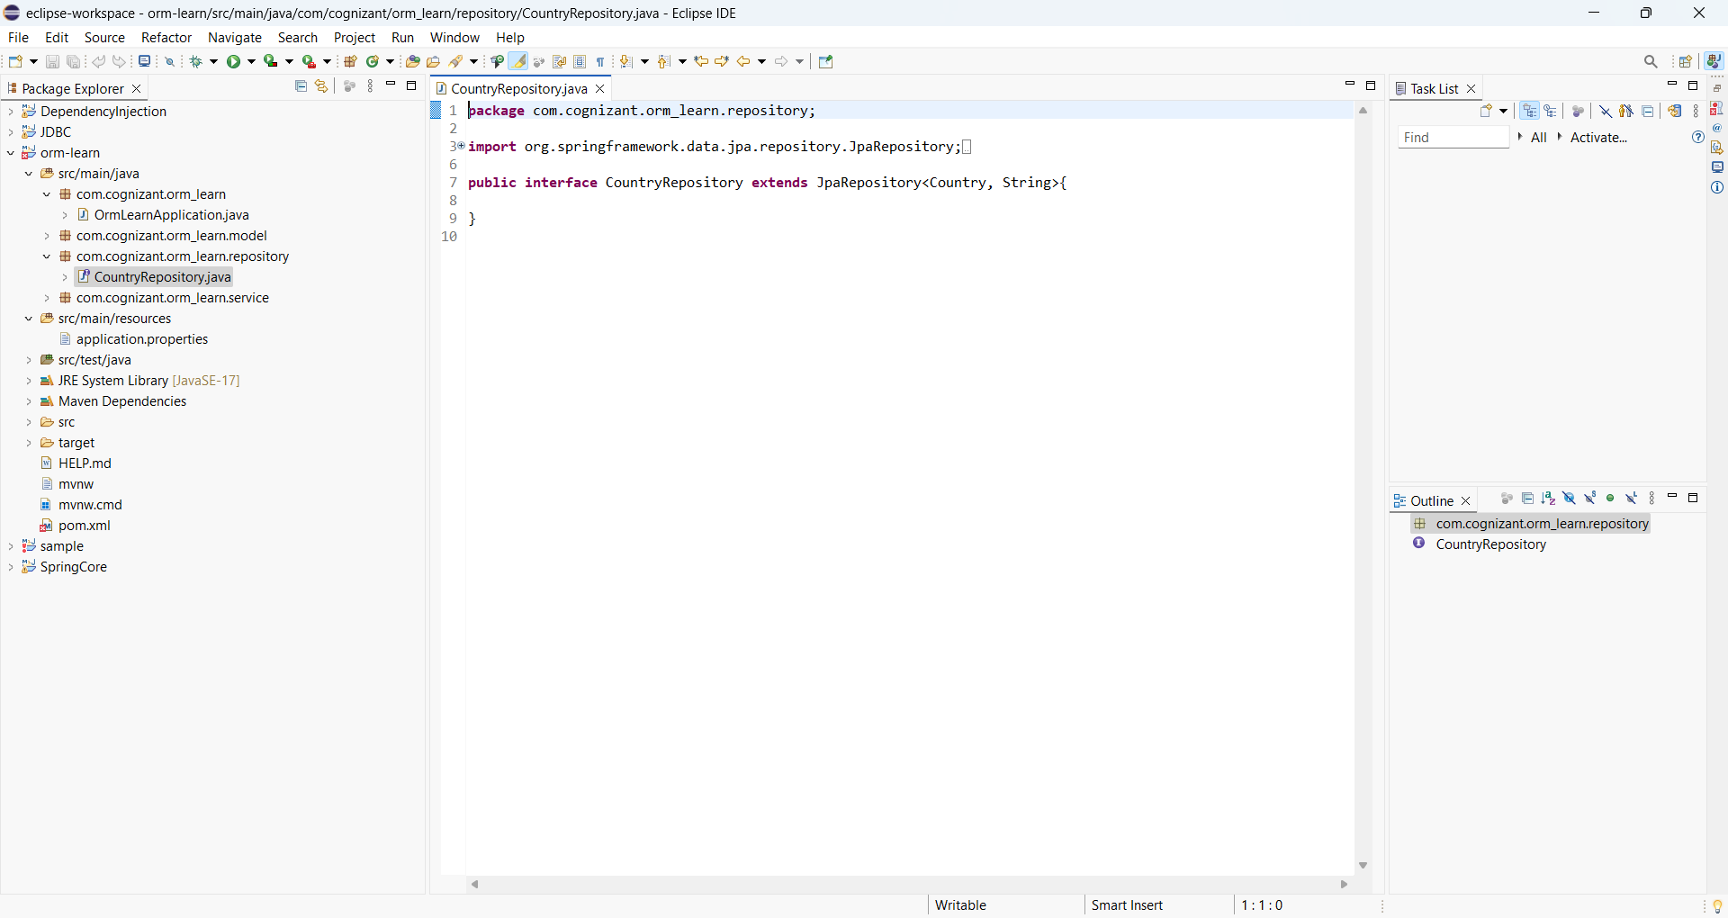

6. com.cognizant.orm_learn.service package

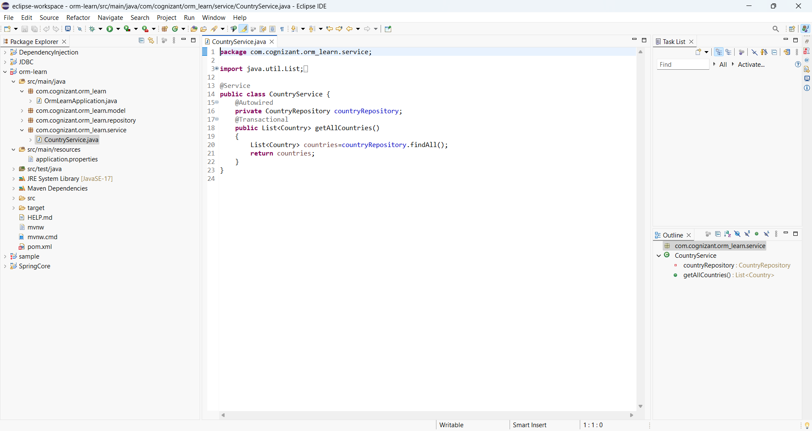

7.OUTPUT

